**APPLICATION CODE**

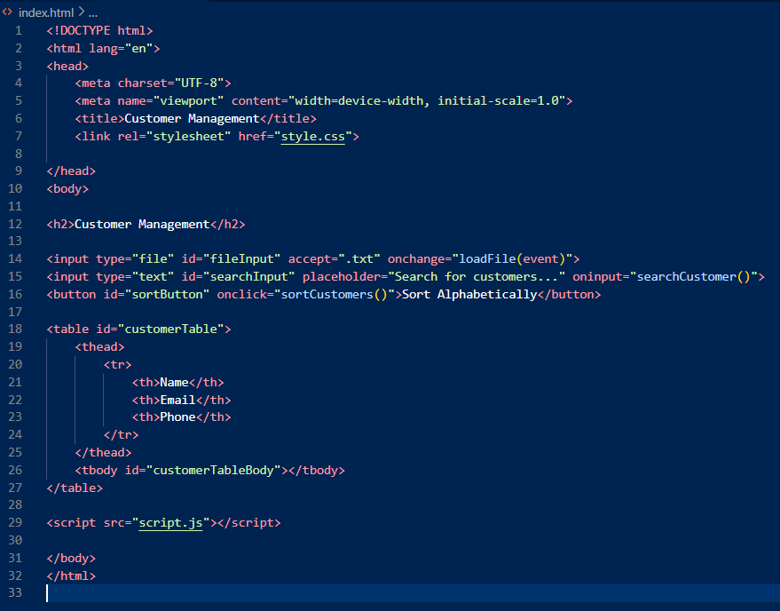

JAVASCRIPT

let customers = [];

function loadFile(event) {

    const file = event.target.files[0];

    if (!file) {

        console.error("No file selected.");

        return;

    }

    const reader = new FileReader();

    reader.onload = (e) => {

        const content = e.target.result;

        console.log("File content:", content);

        const lines = content.split('\n');

        customers = lines.map(line => {

            const [name, email, phone] = line.split(',');

            return { name: name ? name.trim() : "", email: email ? email.trim() : "", phone: phone ? phone.trim() : "" };

        }).filter(customer => customer.name);

        console.log("Parsed customers:", customers);

        displayCustomers(customers);

    };

    reader.readAsText(file);

}

function displayCustomers(customerList) {

    const tableBody = document.getElementById("customerTableBody");

    tableBody.innerHTML = "";

    customerList.forEach((customer) => {

        const row = document.createElement("tr");

        row.innerHTML = `

            <td>${customer.name}</td>

            <td>${customer.email}</td>

            <td>${customer.phone}</td>

        `;

        tableBody.appendChild(row);

    });

}

function sortCustomers() {

    console.log("Sorting customers...");

    customers.sort((a, b) => a.name.localeCompare(b.name));

    displayCustomers(customers);

}

function searchCustomer() {

    const searchTerm = document.getElementById("searchInput").value.toLowerCase();

    console.log("Searching for:", searchTerm);

    const filteredCustomers = customers.filter(customer =>

        customer.name.toLowerCase().includes(searchTerm)

    );

    console.log("Filtered Customers:", filteredCustomers);

    displayCustomers(filteredCustomers);

}

if (typeof module !== 'undefined') {

    module.exports = { loadFile, displayCustomers, sortCustomers, searchCustomer, customers };

}

**TEST REPORTS**

> customermanagement@1.0.0 test  
> jest

console.log

Sorting customers...

at log (script.js:42:13)

console.log

Searching for: alice

at log (script.js:49:13)

console.log

Filtered Customers: [

{

name: 'Alice Smith',

email: 'alice@example.com',

phone: '234-567-8901'

}

]

at log (script.js:53:13)

npm : PASS ./script.test.js

At line:1 char:1

+ npm test > test-log.txt 2>&1

+ CategoryInfo : NotSpecified: (PASS ./script.test.js:String) [], RemoteException

+ FullyQualifiedErrorId : NativeCommandError

Customer Management Tests

ÔêÜ Sort customers alphabetically (50 ms)

ÔêÜ Search for a customer by name (13 ms)

Test Suites: 1 passed, 1 total  
Tests: 2 passed, 2 total  
Snapshots: 0 total  
Time: 1.235 s

**Ran all test suites.**

**THE INITIAL INTERFACE**

**THE USER SELECTS THE customer.txt file with customer details and uploads it to the system**

**THE CUSTOMER NAMES ARE SORT ALPHABETICALLY AFTER USER CLICKS “Sort Alphabetically” button**

**WHEN USER SEARCHES i.e. “john” THE APPLICATION DISPLAYS ANY CUSTOMER WITH “john” IN THEIR NAME AND DISPLAYS THEM ONLY**

